# Recommendations for the Rideau Institute Website

## Home and default layout

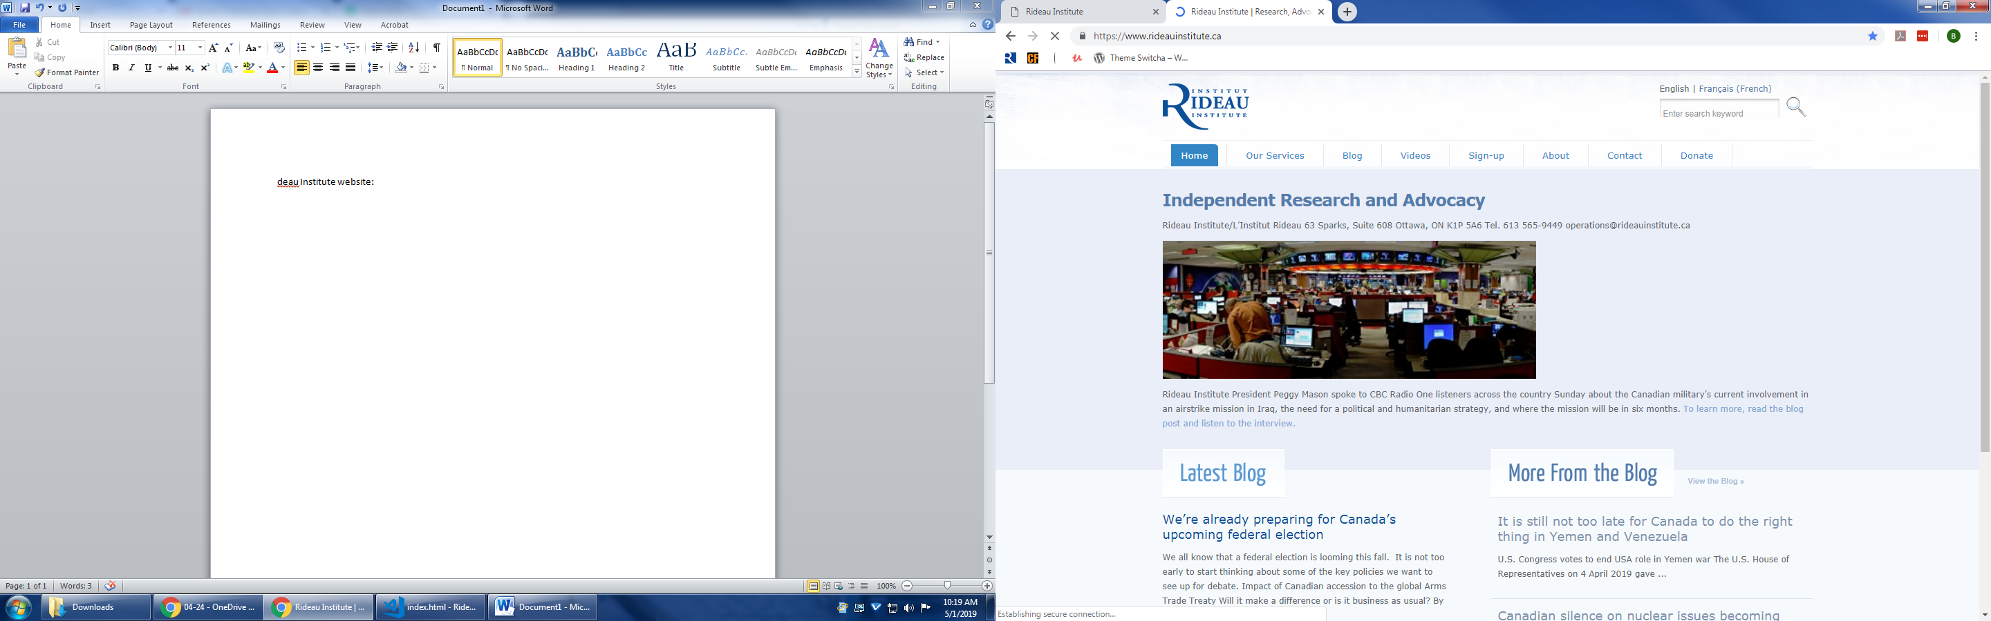

1. Too much space around the page

2. The menu has inconsistent formatting, and it should be more visible

3. The about page has unnecessary sublevels, maybe consolidate them or split a few things in a new session

4. The Donate button should be highlighted, perhaps a bright/different colour

5. The French page gives a 404 error, and the Search box has a persistent text (it should erase it when I type it)

6. The showcase image is not in the right size; the title and the captions are outdated; the contact info should be at the bottom of the page; the link goes to an outdated 2014 article

7. More images on the blog roll. Evaluate the focus of the section and if it is necessary to have it on all pages

8. Add bottom part with subscription field, contact, some info, the about us link

9. Add a publications and events section for the institute studies

## Our services

Just three lines of text, maybe add to the about section.

## Blog

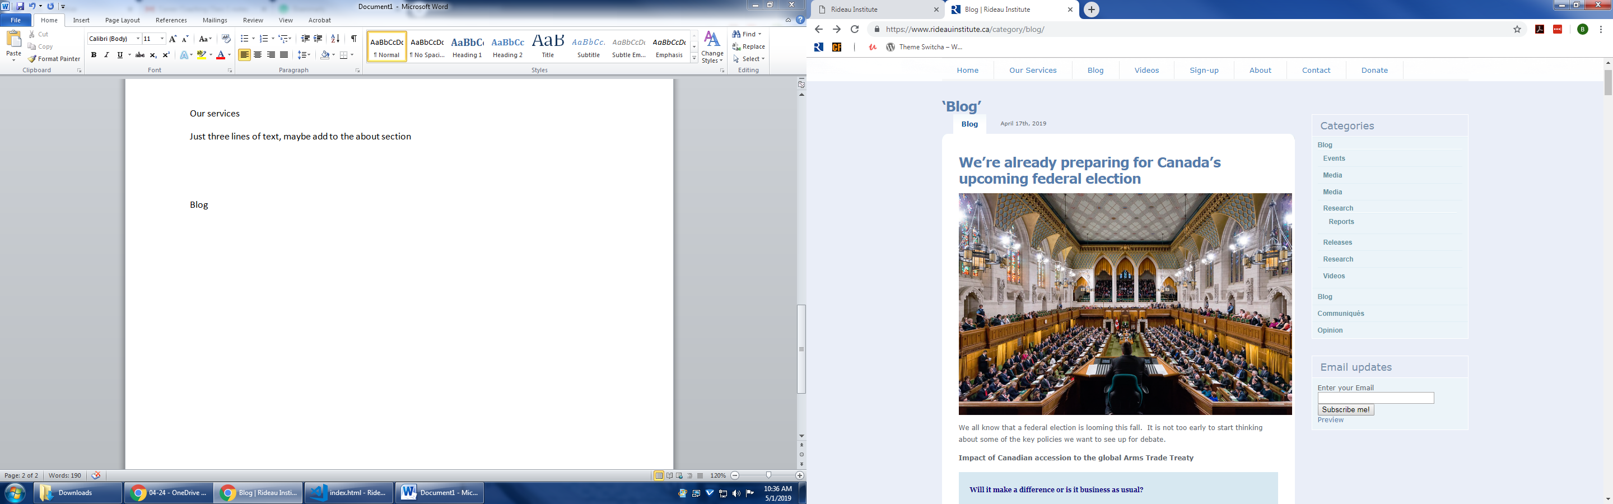

1. It has ‘blog’ written too many times, redundant

2. Change the date place and formatting

3. Maybe putting only the thumbnail and the lead of the article instead of the whole text, make it clickable for the full content

4. Inconsistent formatting on the sidebar, inconsistent sublevels and duplicate information

5. The preview goes to an error page



6. The page is too long due to full text, links to older articles are tiny at the bottom of the page

7. Social media options should be at the top of the article

## Sign-up

Evaluate the need for the signup page. Maybe it is better to put on another part on the front page and have it on the bottom of every page.

## About

Maybe split them into 2: one for the services/history/mission statement and another one for staff, directors and internship information (or put the internship info in a 3rd page).

## Contact

Add at the bottom of every page and in the about us page.

## Donate

Add online option like ceasefire.ca.

## Publications/Videos/Events

Add a section for the pdf files, the videos and the events, but not like an article, instead put thumbnails and make it clickable. It will open on another page.

# Proposed Layout

